Report
Of
Python Programming and Data Analysis
using Trained Datasets

Submitted
To
School of Computer Science and Engineering
IILM University, Greater Noida, U.P.

In partial fulfilment of the requirement of degree of
B.Tech CSE



By
Roll Number of Student: CS-2341851
Name of Student: YASH MAHATO
Batch:

2026-27

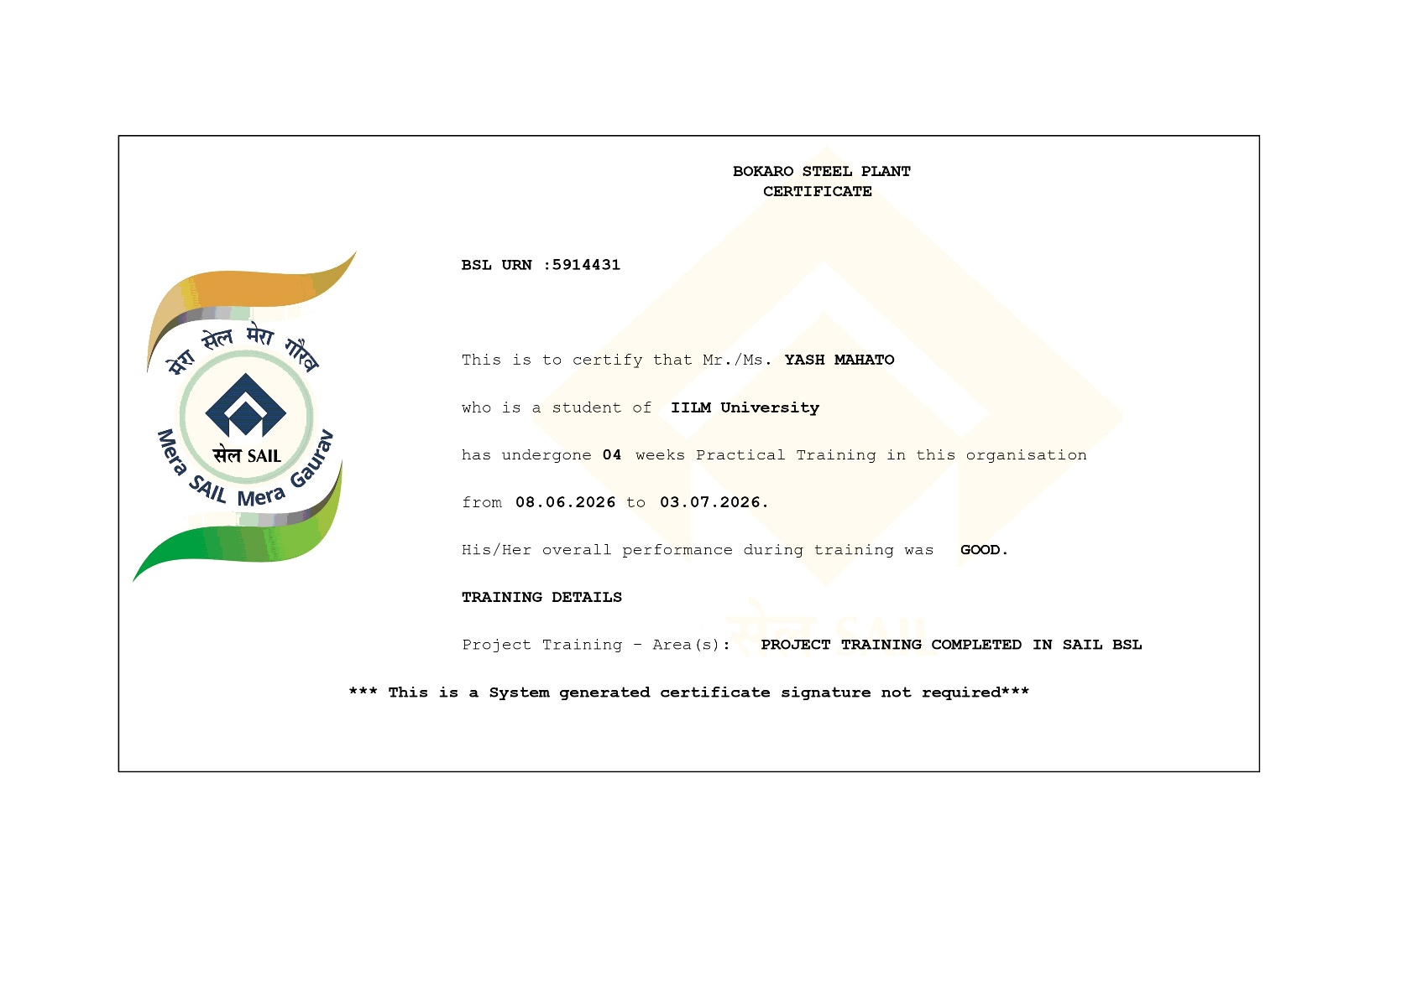

CANDIDATE’S DECLARATION

I, YASH MAHATO do hereby declare that the internship report titled “Python Programming and Data Analysis Using Trained Datasets” has been completed by me to fulfil the requirement for the award of the degree of Bachelor of Technology in CSE. All the references have been quoted and I have not taken as such any material from any other source. I affirm to you that this report is my own and has not been submitted to any other institute for any degree/diploma requirement and further I shall be solely responsible for any kind of copyright violation in this regard.

Signature
Student Name YASH MAHATO
Roll No. CS-2341851

ACKNOWLEDGEMENT

I am using this opportunity to express my gratitude to everyone who supported me throughout the Internship Program. I am thankful for their aspiring guidance, invaluably constructive criticism and friendly advice during this work. I am sincerely grateful to them for sharing their truthful and illuminating views on a number of issues related to this work.
I express my gratitude to my parents for their blessings.

Signature
Student Name YASH MAHATO
Roll No. CS-2341851

 | Chapter Name | Page Nos.
 | Cover Page | ----
1. | Candidate’s Declaration
2. | Acknowledgment
3. | Internship Completion Certificate
4. | Project Description  4 .1 Introduction  4.2 Organization Profile  4.3 Problem Statement  4.4 Project Objectives  4.5 Scope of the Project  4.6 Technologies and Tools Used  4.7 System Architecture  4.8 Methodology  4.9 Expected Outcomes  4.10 Certificates of completion and other communication mail proof must be attached
5. | Bibliography/References

CHAPTER 4: PROJECT DESCRIPTION

4.1 Introduction
This report presents the details of the vocational/industrial training undertaken at Bokaro Steel Plant (BSL), a unit of Steel Authority of India Limited (SAIL), Jharkhand, as part of the curriculum requirement for the degree of Bachelor of Technology in Computer Science and Engineering. The training was carried out for a duration of four weeks, from 08.06.2026 to 03.07.2026, and was aimed at providing practical exposure to real-world computing environments, industrial data systems, and hands-on experience in programming using Python, with a specific focus on working with trained datasets for data analysis and predictive tasks.
As a third-year student of the Computer Science and Engineering branch, this internship offered an opportunity to bridge the gap between theoretical classroom knowledge and its practical application in an industrial setting. The training primarily involved understanding how large-scale organisations manage, process, and analyse operational data using Python-based tools, and how trained machine learning datasets can be leveraged to support data-driven decision making.

4.2 Organization Profile
Bokaro Steel Plant (BSL) is one of the largest integrated steel plants under the Steel Authority of India Limited (SAIL), a Maharatna Central Public Sector Enterprise under the Ministry of Steel, Government of India. Established with technical collaboration from the erstwhile Soviet Union, Bokaro Steel Plant is located in the city of Bokaro Steel City, Jharkhand, and is one of the major contributors to India's steel production capacity.
The plant comprises multiple production units including coke ovens, blast furnaces, steel melting shops, and rolling mills, and is supported by a robust information technology infrastructure that manages production planning, inventory control, quality monitoring, and administrative operations. The organisation regularly hosts vocational trainees from various engineering colleges and universities across the country, providing them exposure to both core industrial processes and the digital/IT systems that support plant operations.

4.3 Problem Statement
Modern industrial organisations generate large volumes of operational and process-related data on a daily basis. Manually analysing this data is time-consuming and prone to error, making it difficult to derive timely and accurate insights. There is a need for efficient, Python-based tools and scripts that can clean, process, and analyse such datasets, and where applicable, apply trained machine learning models to identify patterns, trends, and anomalies that can support better decision-making within the organisation.

4.4 Project Objectives
The key objectives of the internship and the associated project work were as follows:
- To gain practical exposure to Python programming in an industrial environment.
- To understand the process of collecting, cleaning, and pre-processing real-world datasets.
- To work with trained datasets and apply basic machine learning/data analysis concepts using Python libraries.
- To analyse data trends and generate meaningful visualisations and reports.
- To understand the overall functioning and organisational structure of a large public sector steel plant.
- To develop professional skills such as teamwork, documentation, and technical communication.

4.5 Scope of the Project
The scope of the project was limited to the study and practical implementation of Python-based data handling techniques on sample/trained datasets made available during the training period. The work focused on data pre-processing, exploratory data analysis, and the application of basic trained models for prediction/classification tasks, along with visualisation of results. The project did not extend to deployment on live production systems of the plant, and was primarily intended as a learning exercise under the guidance of the training supervisors at Bokaro Steel Plant.

4.6 Technologies and Tools Used
The following technologies, languages, and tools were used during the course of the internship:
- Programming Language: Python 3
- Libraries: NumPy, Pandas, Matplotlib, Seaborn, Scikit-learn
- Development Environment: Jupyter Notebook / VS Code
- Data Handling: CSV/Excel based trained datasets
- Version Control: Git (for maintaining code history, wherever applicable)
- Operating System: Windows

4.7 System Architecture
The overall workflow followed a standard data analysis pipeline. Raw/trained datasets were first imported into the Python environment using Pandas. The data was then cleaned to handle missing values, duplicates, and inconsistent formatting. Following this, exploratory data analysis (EDA) was performed to understand the statistical properties and relationships within the data. Where applicable, pre-trained or newly trained machine learning models (using Scikit-learn) were applied to the processed data to generate predictions or classifications. Finally, the results were visualised using Matplotlib and Seaborn to present clear and interpretable insights.
This pipeline can be summarised in the following stages: Data Collection → Data Cleaning and Pre-processing → Exploratory Data Analysis → Model Training/Testing → Result Visualisation → Report Generation.

4.8 Methodology
The methodology adopted during the internship involved a structured, step-by-step approach. Initially, an orientation session was conducted to familiarise trainees with the organisational structure and IT infrastructure of Bokaro Steel Plant. This was followed by hands-on sessions on Python programming fundamentals, after which trainees were introduced to working with datasets.
- Understanding the dataset structure, features, and target variables.
- Performing data cleaning operations such as handling null values and outliers using Pandas.
- Conducting exploratory data analysis to identify trends, correlations, and distributions.
- Splitting the dataset into training and testing sets.
- Applying appropriate machine learning algorithms on the trained dataset and evaluating model performance.
- Visualising the results using graphs and charts for better interpretability.
- Documenting the observations, challenges faced, and learnings throughout the process.

4.9 Expected Outcomes
Upon completion of the internship, the following outcomes were achieved:
- A working understanding of how Python is used for real-world data analysis in an industrial setting.
- Practical experience in cleaning, processing, and analysing trained datasets.
- Improved proficiency in Python libraries such as Pandas, NumPy, Matplotlib, and Scikit-learn.
- Enhanced understanding of the organisational and operational aspects of Bokaro Steel Plant.
- Development of professional and analytical skills applicable to future academic and industry projects.


4.10 Certificates of Completion

CHAPTER 5: BIBLIOGRAPHY/REFERENCES
1. Steel Authority of India Limited (SAIL) – Official Website: https://www.sail.co.in
2. McKinney, W., "Python for Data Analysis", O'Reilly Media.
3. Pandas Documentation: https://pandas.pydata.org/docs/
4. Scikit-learn Documentation: https://scikit-learn.org/stable/
5. Matplotlib Documentation: https://matplotlib.org/stable/index.html
6. Internship Completion Certificate

